**Q write a program to check the testcase of Fibonacci series using J unit ?**

Code:

**Fibonacci.java**

package junitcode;

import java.util.*;

public class fibonacci {

public static int fib(int i){

if(i==0) {

return 0;

}

if(i==1) {

return 1;

}

else {

return fib(i-1)+fib(i-2);

}

}

public static void main(String[] args) {

}

}

**Test.java**

package junitcode;

import java.util.*;

import static org.junit.Assert.*;

import org.junit.Test;

public class testcase {

@Test

public void test() {

fibonacci obj=new fibonacci();

Scanner s =new Scanner(System.in);

int i=0;

i=s.nextInt();

int output=obj.fib(i);

if(output>2) {

assertEquals((obj.fib(i-1)+obj.fib(i-2)),output);

//assertEquals(8,output);

}

if(output==1) {

assertEquals(1,output);

}

if(output==0) {

assertEquals(0,output);

}}}

**Output:**

**Test case -> Fail:**

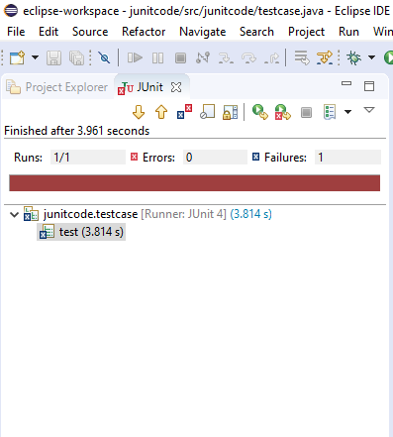

**Test case -> Passes:**

